

SCHOOL OF COMPUTER SCIENCE AND ENGINEERING

DEPARTMENT OF COMPUTER SCIENCE

UNIT – I – Computer Networks and Design – SCSA1502

FUNDAMENTALS OF NETWORK DESIGN

Design Principles - Determining Requirements - Analysing the Existing Network - Preparing the Preliminary Design - Completing the Final Design Development - Deploying the Network - Monitoring and Redesigning – Maintaining - Design Documentation - Modular Network Design - Hierarchical Network Design.
INTRODUCTION
Network designers ensure that our communications networks can adjust and scale to the demands for new services. To support our network-based economy, designers must work to create networks that are available nearly 100 percent of the time. Information network security must be designed to automatically fend off unexpected security incidents. Using hierarchical network design principles and an organized design methodology, designers create networks that are both manageable and supportable.
NETWORK DESIGN CONCEPTS
What is the design methodology used by network designers?
- Network designers ensure that our communications networks can adjust and scale to the demands for new services.
- To support our network-based economy, designers must work to create networks that are available nearly 100 percent of the time.
- Information network security must be designed to automatically fend off unexpected security incidents.
- Using hierarchical network design principles and an organized design methodology, designers create networks that are both manageable and supportable

Basics of network design:
- Network design overview
- The benefits of a hierarchical network design
- Network design methodology

NETWORK DESIGN OVERVIEW
Computers and information networks are critical to the success of businesses, both large and small. They connect people, support applications and services, and provide access to the resources that keep the businesses running. To meet the daily requirements of businesses, networks themselves are becoming quite complex.
Today, the Internet-based economy often demands around-the-clock customer service. This means that business networks must be available nearly 100 percent of the time. They must be smart enough to automatically protect against unexpected security incidents. These business networks must also be able to adjust to changing traffic loads to maintain consistent application response times. It is no longer practical to construct networks by connecting many standalone components without careful planning and design.

DISCOVERING NETWORK DESIGN BASICS
The sections that follow cover the basics of network design with regard to the following concepts:
- Network design overview
- The benefits of a hierarchical network design
- Network design methodology

Network Design Overview
Computers and information networks are critical to the success of businesses, both large and small. They connect people, support applications and services, and provide access to the resources that keep the businesses running. To meet the daily requirements of businesses, networks themselves are becoming quite complex.
NETWORK REQUIREMENTS
Today, the Internet-based economy often demands around-the-clock customer service. This means that business networks must be available nearly 100 percent of the time. They must be smart enough to automatically protect against unexpected security incidents. These business networks must also be able to adjust to changing traffic loads to maintain consistent application response times. It is no longer practical to construct networks by connecting many standalone components without careful planning and design.
Technical Requirements:
- Applications that are to run on the network
- Internet connections required
- Addressing restrictions, for example, the use of private Internet Protocol (IP) version 4 (IPv4) addresses
- Support for IP version 6 (IPv6) addresses
- Other protocols that are to run on the network (for example, routing protocols)
- Cabling requirements
- Redundancy requirements
- Use of proprietary equipment and protocols
- Existing equipment that must be supported
- Network services required, including quality of service (QoS) and wireless
- How security is to be integrated into the network
- Network solutions required (for example, voice traffic, content networking, and storage networking)
- Network management
- Support for existing applications while new ones are being phased in
- Bandwidth availability.

Requirements Related to Business Issues
- Budget- Capital (for new equipment) and operating (for ongoing expenses).
- Schedule - This could include the phasing out of older applications, hiring of new personnel, and so forth.
- People - Considerations include who will install and operate the network, what skills they have, whether they require training, whether any of these tasks will be outsourced, and so forth.
- Legal Issues include any restrictions on the use and storage of data collected
- History Factors include examining the existing network's structure and determining whether any person or group will block changes or additions.
- Policies Consider whether current organizational policies might restrict the network design.

Most businesses actually have only a few requirements for their network:
- The network should stay up all the time, even in the event of failed links, equipment failure, and overloaded conditions.
- The network should reliably deliver applications and provide reasonable response times from any host to any host.
- The network should be secure. It should protect the data that is transmitted over it and data stored on the devices that connect to it.
- The network should be easy to modify to adapt to network growth and general business changes.
- Because failures occasionally occur, troubleshooting should be easy. Finding and fixing a problem should not be too time-consuming.

Building a Good Network
Good networks do not happen by accident. They are the result of hard work by network designers and technicians, who identify network requirements and select the best solutions to meet the needs of a business.
The steps required to design a good network are as follows:
Step 1. Verify the business goals and technical requirements.
Step 2. Determine the features and functions required to meet the needs identified in Step 1.
Step 3. Perform a network-readiness assessment.
Step 4. Create a solution and site acceptance test plan.
Step 5. Create a project plan.
After the network requirements have been identified, the steps to designing a good network are fol- lowed as the project implementation moves forward. Network users generally do not think in terms of the complexity of the underlying network. They think of the network as a way to access the applications they need, when they need them.
Network Requirements
Most businesses actually have only a few requirements for their network:
The network should stay up all the time, even in the event of failed links, equipment failure, and overloaded conditions. The network should reliably deliver applications and provide reasonable response times from any host to any host. The network should be secure. It should protect the data that is transmitted over it and data stored on the devices that connect to it. The network should be easy to modify to adapt to network growth and general business changes. Because failures occasionally occur, troubleshooting should be easy. Finding and fixing a problem should not be too time-consuming.
FUNDAMENTAL DESIGN GOALS
When examined carefully, these requirements translate into four fundamental network design goals:
Scalability: Scalable network designs can grow to include new user groups and remote sites and can support new applications without impacting the level of service delivered to existing users.
Availability: A network designed for availability is one that delivers consistent, reliable perform- ance, 24 hours a day, 7 days a week. In addition, the failure of a single link or piece of equipment should not significantly impact network performance.
Security: Security is a feature that must be designed into the network, not added on after the net- work is complete. Planning the location of security devices, filters, and firewall features is critical to safeguarding network resources.
Manageability: No matter how good the initial network design is, the available network staff must be able to manage and support the network. A network that is too complex or difficult to maintain cannot function effectively and efficiently.

NETWORK DESIGN
Implementation Components
Implementation of a network design consists of several phases (install hardware, configure systems, launch into production, and so on).
Each phase consists of several steps, and each step should contain, but be not limited to, the following documentation:
- Description of the step
- Reference to design documents
- Detailed implementation guidelines
- Detailed roll-back guidelines in case of failure
- Estimated time needed for implementation

Analysing the Existing Network
The second step of the design methodology is characterizing the existing network and sites
The following sections present insights into the process of examining an existing network and sites and describe the tools used to gather the data, assess the network, and analyze the network.
- Customer input: Review existing documentation about the network, and use verbal input from the customer to obtain a first impression about the network
- Network audit: Perform a network audit, also called an assessment, which reveals details of the network and augments the customer’s description
- Traffic analysis: If possible, use traffic analysis to provide information about the applications and protocols used and to reveal any shortcomings in the network.
- Customer input: includes all pertinent network and site documentation.

Some items the designer could request, depending on the scope of the project, include the following:
- Site contact information (especially needed if remote deployments are planned)
- Existing network infrastructure (from physical diagrams and documents, and site surveys as needed), including the following
Locations and types of servers, Locations and types of network devices Cabling that is currently in place Environmental controls, including heating, ventilation, and air conditioning requirements, and filtration Locations of power receptacles etc

- Existing network infrastructure from logical topology diagrams, routing protocols in use, and the infrastructure services supported, such as voice, storage, and wireless services
- Network topology: Includes devices, physical and logical links, external connections, bandwidth of connections, frame types (data link encapsulations), IP addressing, routing protocols, and so forth.
- Network services: Includes security, QoS, high availability, voice, storage, wireless, and so forth.
- Network applications: Examples include unified messaging and video delivery
- The Second important step is network audit or assessment
- It is used to collect information about an existing network

An audit provides details such as:
- A list of network devices
- Hardware specifications and versions, and software versions of network devices
- Configurations of network devices
- Output of various auditing tools to verify and augment the existing documentation
- Link, CPU, and memory utilization of network devices
- A list of unused ports, modules, and slots in network devices, (to be used to understand whether the network is expandable)

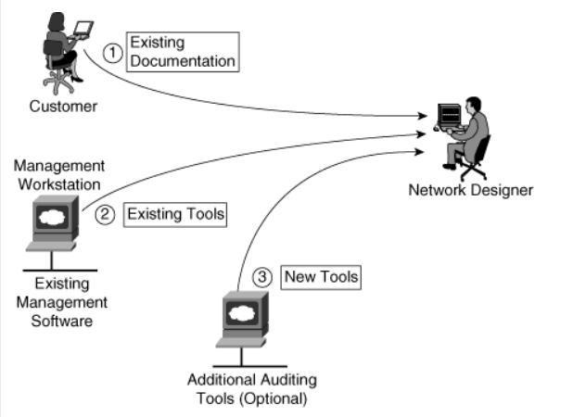
Existing Network system auditing sources

PREPARING THE PRELIMINARY DESIGN:
- Preliminary design involves considering all the network requirements and constraints (including the budget), and determining viable alternative solutions.
- The network owner consulted, and together an optimal solution is chosen
- This solution is later developed into the final design
(Both the preliminary design and final design are done Using PDIOO)

FOLLOWING A DESIGN METHODOLOGY CAN HAVE MANY ADVANTAGES:
- It ensures that no step is missed when the process is followed
- It provides a framework for the design process deliverables
- It encourages consistency in the creative process, enabling network designers to set appropriate deadlines and maintain customer and manager satisfaction.
- It allows customers and managers to validate that the designers have thought about how to meet their requirements

Preliminary Design Step involves in the preparation of detailed Documentation of the network
It is achieved by collecting information from customer, inspecting the site, and accessing the network using Automated Tools

Different Approaches:
- Top Down Approach:
A top-down approach to network design means that requirements are considered first, with the applications and network solutions that will run on the network driving the design

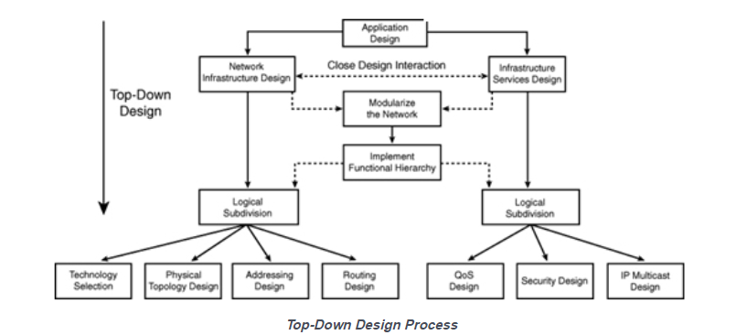

Top-Down Approach

- Bottom- Up Approach:
A bottom-up approach would first select devices, features, cabling, and so on, and then try to fit the applications onto this network
Issues in Bottom-Up Approach
A bottom-up approach can lead to redesign if the applications are not accommodated properly.
This approach can also result in increased costs by including features or devices that are not required
A bottom-up approach would first select devices, features, cabling, and so on, and then try to fit the applications onto this network

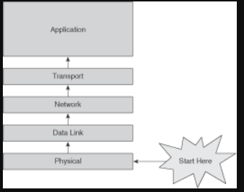
Bottom-Up Approach
Issues in Bottom-Up Approach
A bottom-up approach can lead to redesign if the applications are not accommodated properly. This approach can also result in increased costs by including features or devices that are not required

THE BENEFITS OF A HIERARCHICAL NETWORK DESIGN
To meet the four fundamental design goals, a network must be built on an architecture that allows for both flexibility and growth.

Hierarchical Network Design
In networking, a hierarchical design is used to group devices into multiple networks. The networks are organized in a layered approach. The hierarchical design model has three basic layers:
Core layer: Connects distribution layer devices
Distribution layer: Interconnects the smaller local networks
Access layer: Provides connectivity for network hosts and end devices

Hierarchical networks have advantages over flat network designs. The benefit of dividing a flat network into smaller, more manageable hierarchical blocks is that local traffic remains local. Only traffic destined for other networks is moved to a higher layer. Layer 2 devices in a flat network provide little opportunity to control broadcasts or to filter undesirable traffic. As more devices and applications are added to a flat network, response times degrade until the network becomes unusable. Figures 1-1 and 1-2 show the advantages of a hierarchical network design versus a flat network design.

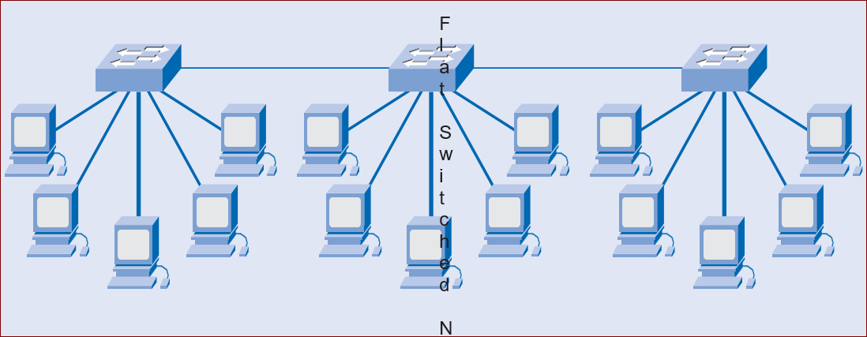
Figure 1.1 Flat Network
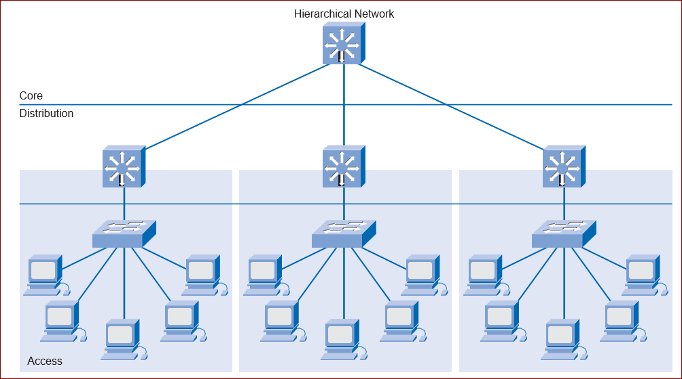
Figure 1.2 Hierarchical Network (Three Separate Broadcast Domains)
Modular Design of Cisco Enterprise Architectures
The Cisco Enterprise Architectures (see Figure 1-3) can be used to further divide the three-layer hierarchical design into modular areas. The modules represent areas that have different physical or logical connectivity. They designate where different functions occur in the network. This modularity enables flexibility in network design. It facilitates implementation and troubleshooting. Three areas of focus in modular network design are as follows:
Enterprise campus: This area contains the network elements required for independent operation within a single campus or branch location. This is where the building access, building distribution, and campus core are located.
Server farm: A component of the enterprise campus, the data centre server farm protects the server resources and provides redundant, reliable high-speed connectivity.
Enterprise edge: As traffic comes into the campus network, this area filters traffic from the external resources and routes it into the enterprise network. It contains all the elements required for efficient and secure communication between the enterprise campus and remote locations, remote users, and the Internet.

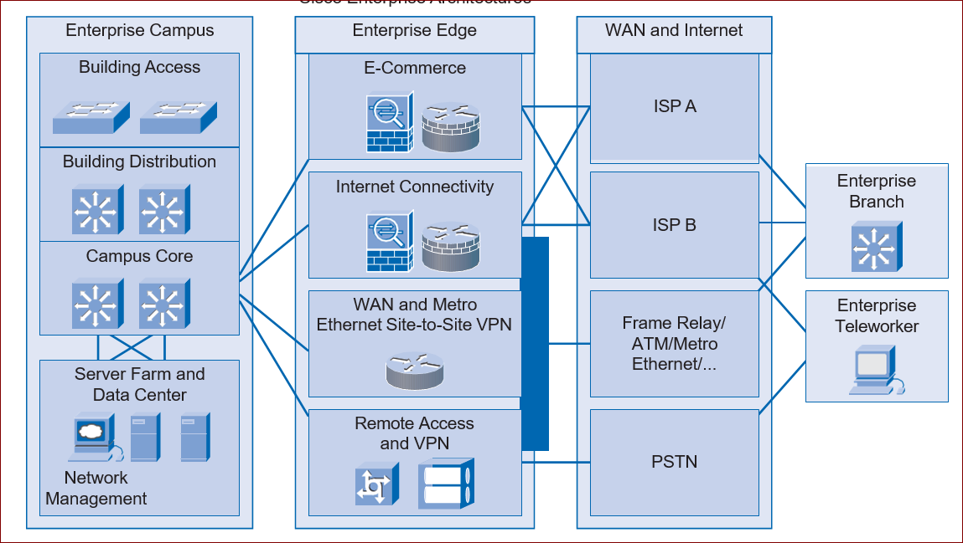
Figure 1.3 Cisco Enterprise Architectures
The modular framework of the Cisco Enterprise Architectures as depicted in Figure 1-4 has the following design advantages: It creates a deterministic network with clearly defined boundaries between modules. This provides clear demarcation points so that the network designer knows exactly where the traffic originates and where it flows. It eases the design task by making each module independent. The designer can focus on the needs of each area separately. It provides scalability by allowing enterprises to add modules easily. As network complexity grows, the designer can add new functional modules. It enables the designer to add services and solutions without changing the underlying network design.
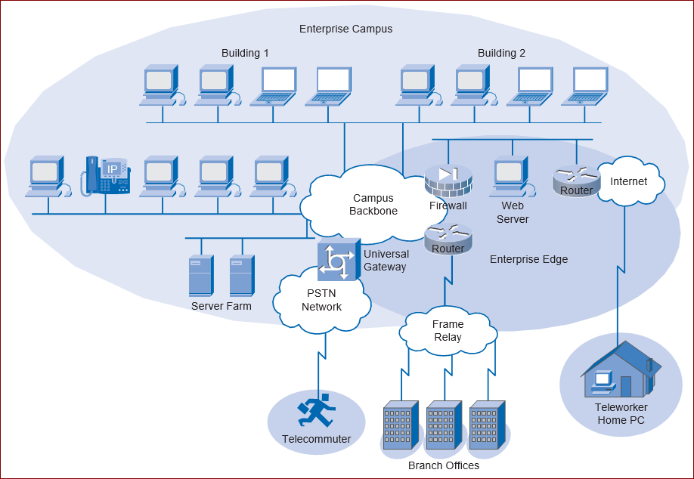
Figure 1-4 Enterprise Campus
Interactive Activity 1-1: Match the Characteristics of the Hierarchal Model and the Cisco Enterprise Architecture (1.1.2) In this interactive activity, you match the characteristics of the hierarchal model and the Cisco Enterprise Architecture to their correct location. Use file ia-112 on the CD-ROM that accompanies this book to perform this interactive activity
NETWORK DESIGN METHODOLOGIES
Large network design projects are normally divided into three distinct steps:
Step 1. Identify the network requirements.
Step 2. Characterize the existing network.
Step 3. Design the network topology and solutions.

Step 1: Identifying Network Requirements
The network designer works closely with the customer to document the goals of the project. Figure 1-5 depicts a meeting between the designer and the business owner. Goals are usually separated into two categories:
Business goals: Focus on how the network can make the business more successful
Technical requirements: Focus on how the technology is implemented within the network

Step 2: Characterizing the Existing Network
Information about the current network and services is gathered and analysed. It is necessary to compare the functionality of the existing network with the defined goals of the new project. The designer determines whether any existing equipment, infrastructure, and protocols can be reused, and what new equipment and protocols are needed to complete the design.

Step 3: Designing the Network Topology
A common strategy for network design is to take a top-down approach. In this approach, the network applications and service requirements are identified, and then the network is designed to support them. When the design is complete, a prototype or proof-of-concept test is performed. This approach ensures that the new design functions as expected before it is implemented.


Figure 1-5 Enterprise Campus

A common mistake made by network designers is the failure to correctly determine the scope of the network design project.
Determining the Scope of the Project
While gathering requirements, the designer identifies the issues that affect the entire network and those that affect only specific portions. By creating a topology similar to Figure 1-6, the designer can isolate areas of concern and identify the scope of the project. Failure to understand the impact of a particular requirement often causes a project scope to expand beyond the original estimate. This oversight can greatly increase the cost and time required to implement the new design.
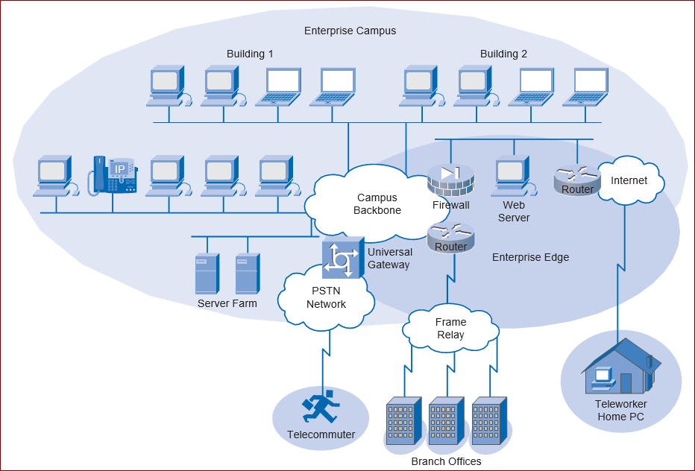
Figure 1-6 Enterprise Campus
Impacting the Entire Network
Network requirements that impact the entire network include the following:
- Adding new network applications and making major changes to existing applications, such as database or Domain Name System (DNS) structure changes
- Improving the efficiency of network addressing or routing protocol changes
- Integrating new security measures
- Adding new network services, such as voice traffic, content networking, and storage networking
- Relocating servers to a data centre server farm

Impacting a Portion of the Network
Requirements that may only affect a portion of the network include the following:
- Improving Internet connectivity and adding bandwidth
- Updating access layer LAN cabling
- Providing redundancy for key services
- Supporting wireless access in defined areas
- Upgrading WAN bandwidth

COMPLETING THE FINAL DESIGN DEVELOPMENT

- During the final design stage the detailed architectural and engineering drawings (the blueprints) of all physical components of the Network components are produced.
- In some complex projects, it is necessary to prepare in addition a written final design report.
- Sufficient detail must be provided by the drawings and the report should have reasonably accurate estimates involved in the process.
- All revisions to materials, equipment specifications are made. The updated schedule, cost estimates and specifications should be available in the final design report.
It is essential to verify at the final design stage that the plan remains economically feasible. If, by some chance it is not, then a decision must be made to revise design solutions or the original concepts, or perhaps terminate the project

Deploying the Network
- Deployment of the network must start with a plan and a schedule.
- Deployment planning starts in the PDIOO Design phase and continues into the Implement phase
- It contains – What to be done? / How to be Done?
- Contingency plans, that is, plans for what happens if a problem occurs during the implementation, should also be included
- Any training required for personnel should be planned during this time
- Any contracts required should be negotiated during this time. Examples include outsourcing, Internet connectivity, maintenance etc.
If all the above said points are in place the we can proceed with the implementation of the network

Monitoring and Redesigning Phase:
- After the network is operating, baseline operational statistics should be gathered so that working status can be identified
- The network should then be monitored for anomalies and problems.
- If problems occurs, or if requirements change or are added, then appropriate design changes must be made and the entire design process should be repeated for that portion of the network.

Note:
Monitoring and redesign take place in the PDIOO Operate and Optimize phases, and can lead back into the Plan and Design phases.

Maintaining Design Documentation:
The design should be documented throughout the process. Documentation should include the following items:
- All the agreed-to requirements and constraints
- The state of the existing network, if any
- Preliminary design options and a brief review of why the final design was chosen
- Final design details
- Results of any pilot or prototype testing
- Deployment plans, schedules, and other implementation details
- Monitoring requirements
- Any other pertinent information

A module is a component of a composite structure Modular network design involves creating modules that can then be put together to meet the requirements of the entire network.

A modular design for a network has many benefits, such as:
- It is easier to understand and design smaller, simpler modules rather than an entire network
- It is easier to troubleshoot smaller elements compared to the entire network
- The reuse of blocks saves design time and effort, as well as implementation time and effort
- The reuse of blocks allows the network to grow more easily, providing network scalability
- It is easier to change modules rather than the entire network, providing flexibility of design.

